**World Population Data analysis with Data Engineering and Data Analytics in Microsoft fabric.**

**Components used:**

* **Web API**
* **Data Pipeline**
* **Lake house**
* **Notebook**
* **Data wrangler**
* **PySpark**
* **Semantic model**
* **Power BI report**

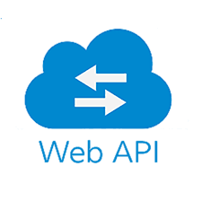

**Data Pipeline**



**Lake House (Bronze Layer)**



**Notebook**

**PySpark**

**Data Wrangler**



**Lake House (Siver Layer)**



**Sematic Model (Gold Layer)**



**Power BI dashboard**

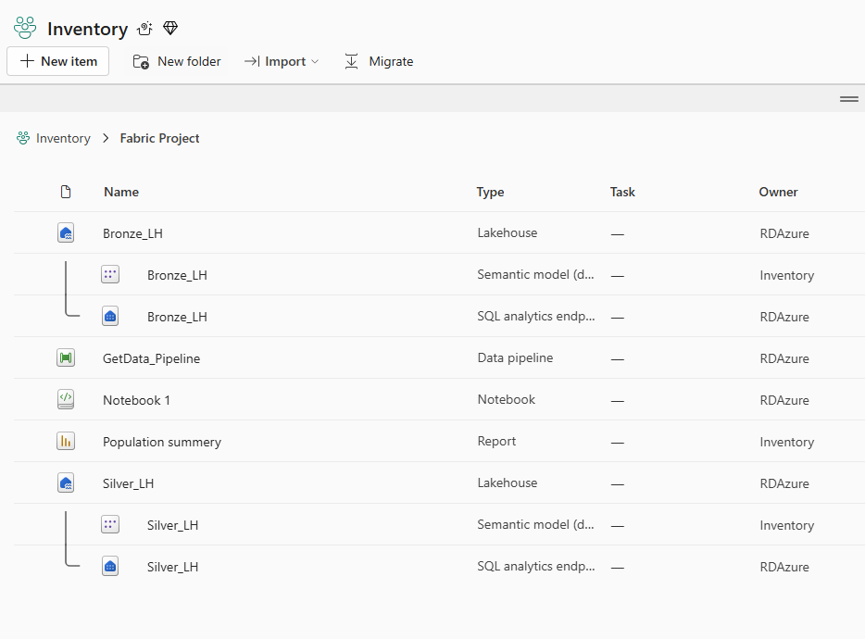

**Source:**

[**https://github.com/ranjustalk/RKSRC/**](https://github.com/ranjustalk/RKSRC/)

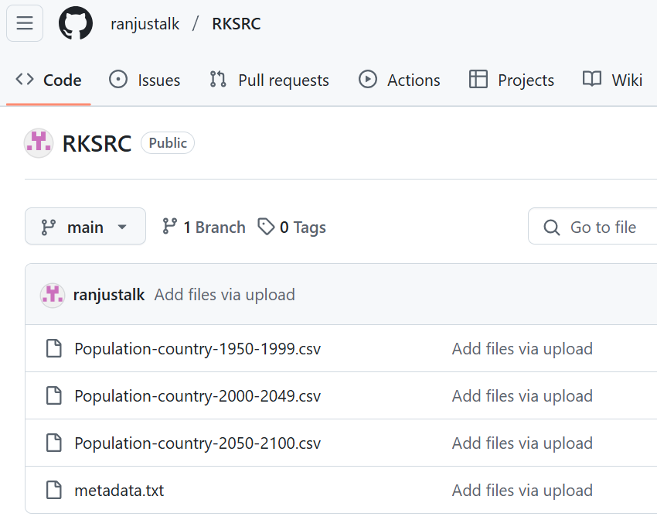

**Connection to Source:**

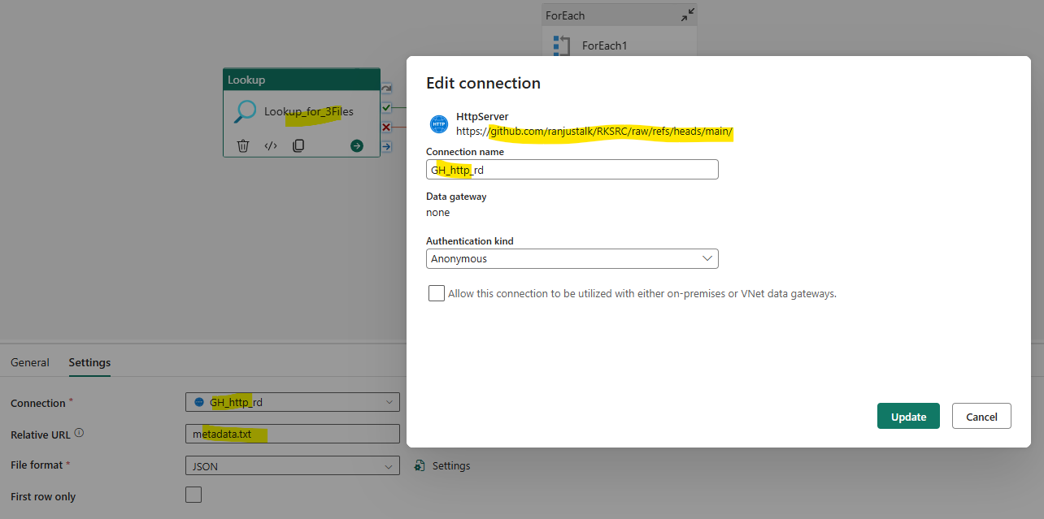

**Bronze layer (Data pipeline):**

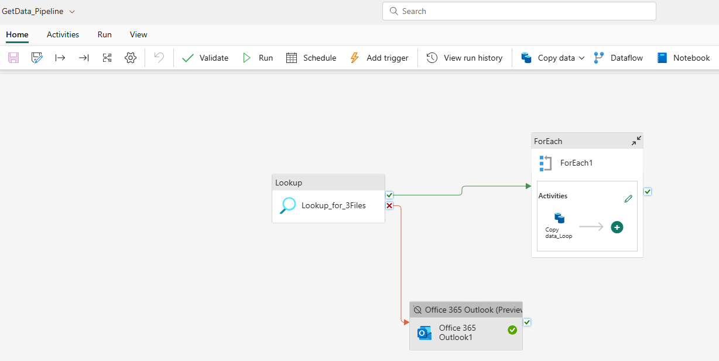

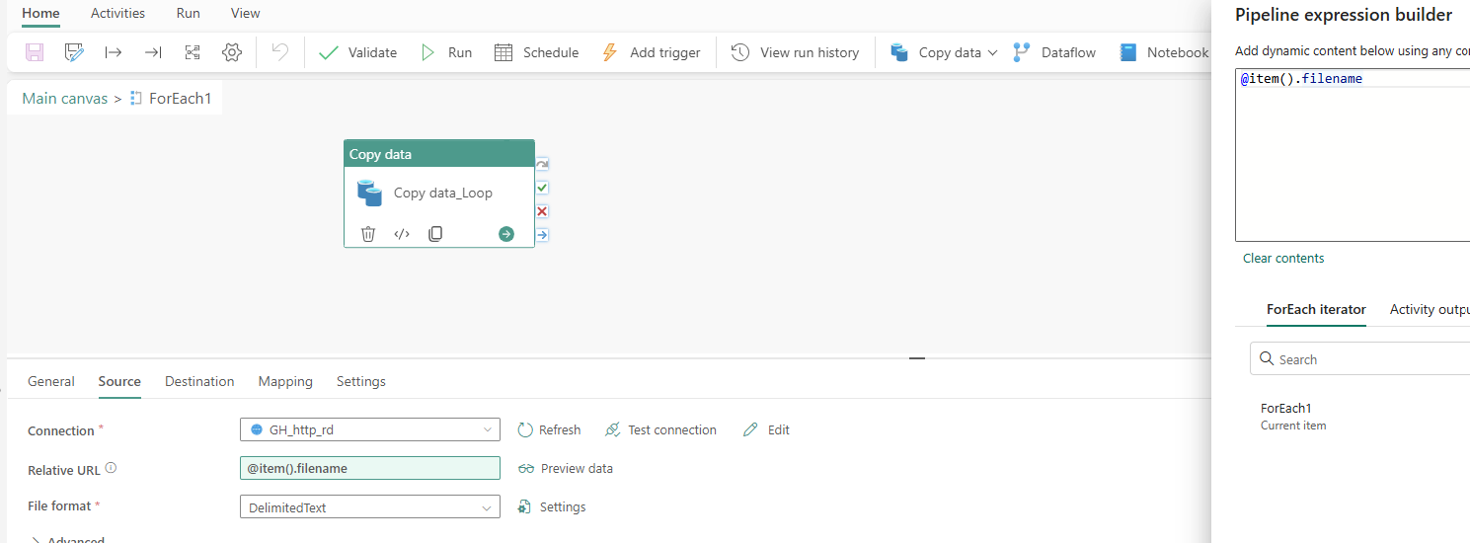

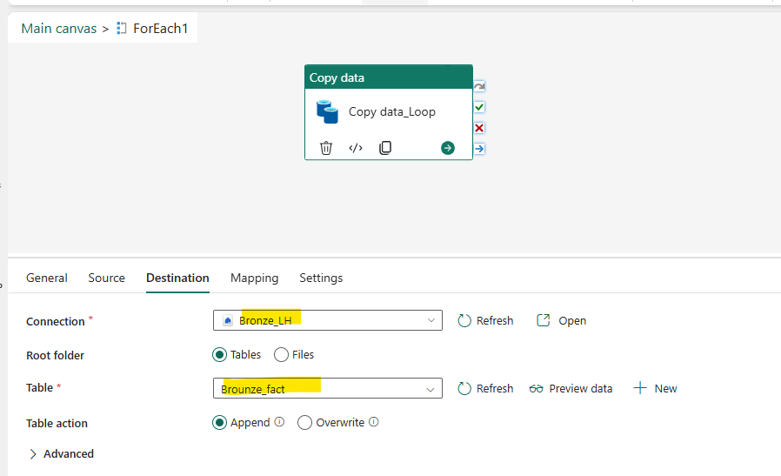

**Silver layer (Notebook):**

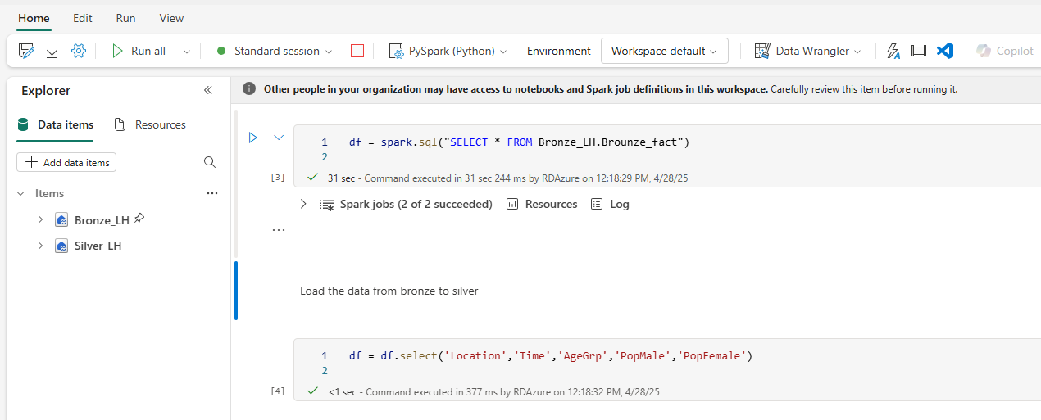Data cleaning and transformation. Using PySpark (Python) and Data Wrangler.

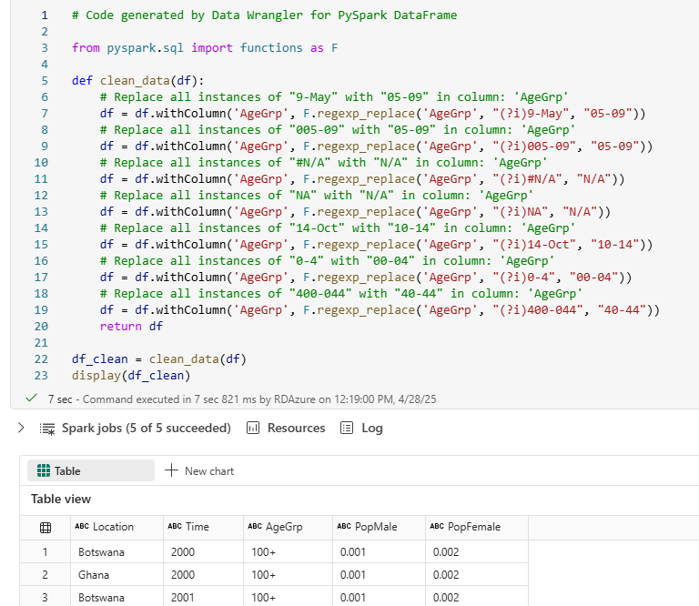

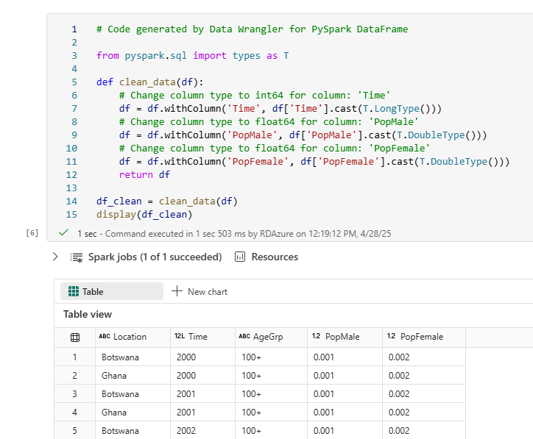

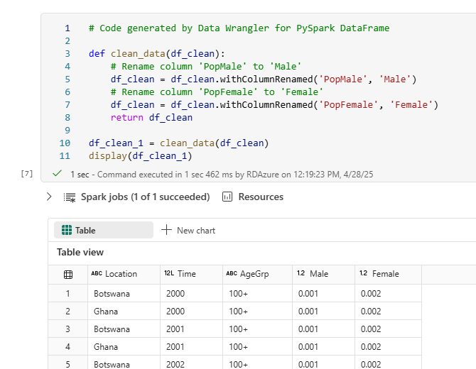

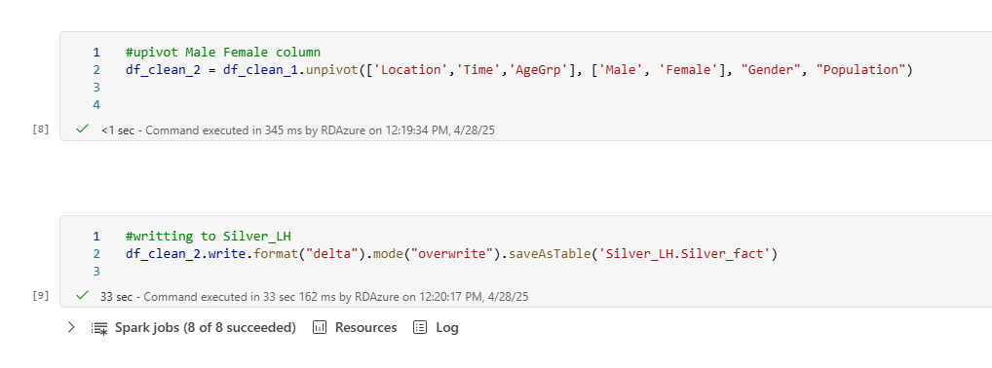

**Gold layer reporting / Dashboarding:**

